Problem Solving and testing

using Java Week-1 Task Questions

Name: V. Neela devi VTU:28598

SESSION-1: Introduction to Functional Programming Concepts
1. Java Lambda Expressions - https://www.hackerrank.com/challenges/java-lambda-expressions/problem

PROBLEM STATEMENT:
This Java 8 challenge tests your knowledge of Lambda expressions!
Write the following methods that return a lambda expression performing a specified action:
- PerformOperation isOdd(): The lambda expression must return TRUE if a number is odd or if it is even.
- PerformOperation isPrime(): The lambda expression must return TRUE if a number is prime or if it is composite.
- PerformOperation isPalindrome(): The lambda expression must return FALSE if a number is a palindrome or if it is not.

Input Format
Input is handled for you by the locked stub code in your editor.

Output Format
The locked stub code in your editor will print lines of output.

Sample Input
The first line contains an integer,T (the number of test cases).
The T subsequent lines each describe a test case in the form of 2-space-separated integers: The first integer specifies the condition to check for (1 for Odd/Even,2 for Prime, or 3 for Palindrome). The second integer denotes the number to be checked.
5
1 4
2 5
3 898
1 3
2 12

Sample Output
EVEN PRIME
PALINDROME ODD COMPOSITE

PROGRAM:
import java.io.*; import java.util.*;
interface PerformOperation {

boolean check(int a);
}
class MyMath {
public static boolean checker(PerformOperation p, int num) { return p.check(num);
}
public PerformOperation isOdd() { return (n) -> n % 2 != 0;
}
// 2. Check Prime
public PerformOperation isPrime() { return (n) -> {
if (n < 2) return false;
for (int i = 2; i <= Math.sqrt(n); i++) { if (n % i == 0)
return false;
}
return true;
};
}
// 3. Check Palindrome
public PerformOperation isPalindrome() { return (n) -> {
int original = n; int reverse = 0;
while (n > 0) {
int digit = n % 10;
reverse = reverse * 10 + digit; n = n / 10;
}
return original == reverse;
}
}
}
public class Solution {
public static void main(String[] args) throws IOException { MyMath ob = new MyMath();
BufferedReader br = new BufferedReader(new InputStreamReader(System.in));

int T = Integer.parseInt(br.readLine()); PerformOperation op;
boolean ret = false; String ans = null; while (T--> 0) {
String s = br.readLine().trim(); StringTokenizer st = new StringTokenizer(s); int ch = Integer.parseInt(st.nextToken()); int num = Integer.parseInt(st.nextToken()); if (ch == 1) {
op = ob.isOdd();
ret = ob.checker(op, num); ans = (ret) ? "ODD" : "EVEN";
}
else if (ch == 2) { op = ob.isPrime();
ret = ob.checker(op, num);
ans = (ret) ? "PRIME" : "COMPOSITE";
}
else if (ch == 3) {
op = ob.isPalindrome(); ret = ob.checker(op, num);
ans = (ret) ? "PALINDROME" : "NOT PALINDROME";

}
System.out.println(ans);
}
}
}

OUTPUT:
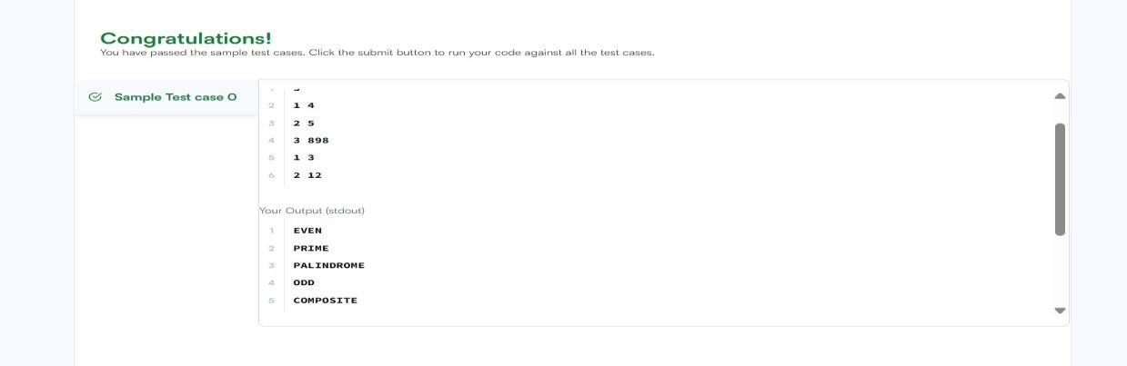

1-2.Programming Concepts : Task 1 in syllabus
Problem Description
A company stores employee salaries in a list. Increase each salary by 10% and print the updated salaries using functional transformation techniques.
Input Format
- First line contains integer N.
- Second line contains N space-separated integers. Output Format
Print updated salaries.
Constraints
- 1 ≤ N ≤ 10^5 Sample Input
5
1000 2000 3000 4000 5000
Sample Output
1100 2200 3300 4400 5500

Program:
package TIMES_DATES; import java.util.*;
import java.util.stream.Collectors; public class sale_management {
public static void main(String[] args) { Scanner sc = new Scanner(System.in); int N = sc.nextInt();
List<Integer> salaries = new ArrayList<>(); for (int i = 0; i < N; i++) {
salaries.add(sc.nextInt());
} // Increase each salary by 10% List<Integer> updated = salaries.stream()
.map(salary -> salary + salary / 10)
.collect(Collectors.toList());
// Print updated salaries for (int s : updated) {
System.out.print(s + " ");
}
sc.close();
}
}

OUTPUT:
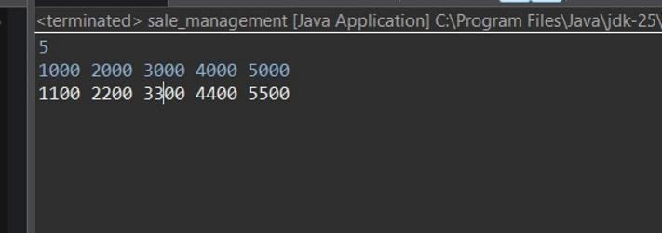

Session 2: Lambda Expressions
- Java Sort – https://www.hackerrank.com/challenges/java-sort/problem

PROBLEM STATEMENT:
You are given a list of student information: ID, FirstName, and CGPA. Your task is to rearrange them according to their CGPA in decreasing order. If two student have the same CGPA, then arrange them according to their first name in alphabetical order. If those two students also have the same first name, then order them according to their ID. No two students have the same ID. Hint: You can use comparators to sort a list of objects. See the oracle docs to learn about comparators.

Input Format
The first line of input contains an integer , representing the total number of students. The next lines contains a list of student information in the following structure:
ID Name CGPA

Constraints:
The name contains only lowercase English letters. The contains only integer numbers without leading zeros. The CGPA will contain, at most, 2 digits after the decimal point.

Output Format
After rearranging the students according to the above rules, print the first name of each student on a separate line.

Sample Input
5
33 Rumpa 3.68
85 Ashis 3.85
56 Samiha 3.75
19 Samara 3.75
22 Fahim 3.76 Sample Output Ashis
Fahim Samara Samiha

Rumpa

Program:
import java.util.*; class Student{ private int id;
private String fname; private double cgpa;
public Student(int id, String fname, double cgpa) { super();
this.id = id; this.fname = fname; this.cgpa = cgpa;
}
public int getId() {
return id;
}
public String getFname() { return fname;
}
public double getCgpa() { return cgpa;
}
}

//Complete the code public class Solution
{
public static void main(String[] args){ Scanner in = new Scanner(System.in);
int testCases = Integer.parseInt(in.nextLine());

List<Student> studentList = new ArrayList<Student>(); while(testCases>0){
int id = in.nextInt(); String fname = in.next();
double cgpa = in.nextDouble();

Student st = new Student(id, fname, cgpa); studentList.add(st);

testCases--;
}
//Complete the code Collections.sort(studentList, (s1, s2) -> {
if (Double.compare(s2.getCgpa(), s1.getCgpa()) != 0) {

return Double.compare(s2.getCgpa(), s1.getCgpa());
}
else if (!s1.getFname().equals(s2.getFname())) { return s1.getFname().compareTo(s2.getFname());
}
else {
return s1.getId() - s2.getId();
}
});

for(Student st: studentList){ System.out.println(st.getFname());
}
}
}
OUTPUT:
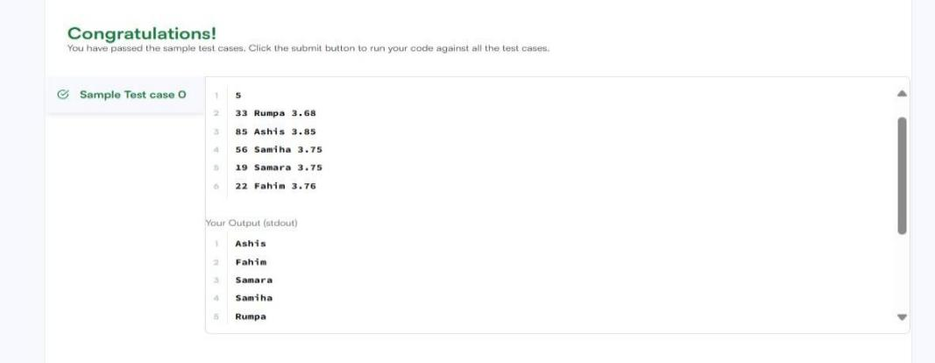
- Sort Array By Parity https://leetcode.com/problems/sort-array-by-parity/

PROBLEM STATEMENT:
Given an integer array nums, move all the even integers at the beginning of the array followed by all the odd integers.
Return any array that satisfies this condition.

Example 1:
Input: nums = [3,1,2,4] Output: [2,4,3,1]
Explanation: The outputs [4,2,3,1], [2,4,1,3], and [4,2,1,3] would also be accepted. Example 2:
Input: nums = [0] Output: [0]

Constraints:
- 1 <= nums.length <= 5000

- 0 <= nums[i] <= 5000

PROGRAM:
class Solution {
public int[] sortArrayByParity(int[] nums) { int left = 0;
int right = nums.length - 1; while (left < right) {
while (left < right && nums[left] % 2 == 0) { left++;
}
while (left < right && nums[right] % 2 != 0) { right--;
}

int temp = nums[left]; nums[left] = nums[right]; nums[right] = temp;

left++; right--;
}
return nums;
}
}

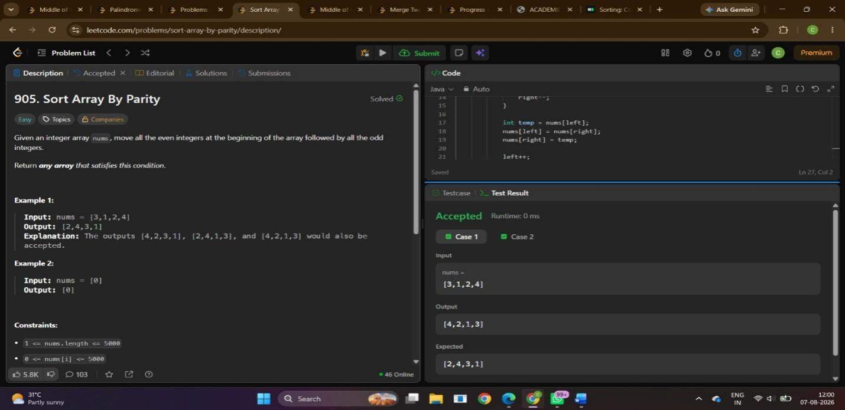
OUTPUT:

SESSION-3: Anonymous Functions & Functional Interfaces
- Sorting: Comparator – https://www.hackerrank.com/challenges/ctci-comparator-sorting/problem

PROBLEM STATEMENT:
Comparators are used to compare two objects. In this challenge, you'll create a comparator and use it to sort an array. The Player class is provided in the editor below. It has two fields:
  - name: a string.
  - score: an integer.
Given an array of n Player objects, write a comparator that sorts them in order of decreasing score. If 2 or more players have the same score, sort those players alphabetically ascending by name. To do this, you must create a Checker class that implements the Comparator interface, then write an int compare(Player a, Player b) method implementing the Comparator.compare(T o1, T o2) method. In short, when sorting in ascending order, a comparator function returns -1 if a , if a<b ,0 and a=b if a>b.
Declare a Checker class that implements the comparator method as described. It should sort first descending by score, then ascending by name. The code stub reads the input, creates a list of Player objects, uses your method to sort the data, and prints it out properly.
Example
n = 3, data = [[Smith, 20], [Jones, 15], [Jones, 20]]
dataSorted = [[Jones, 20], [Smith, 20], [Jones, 15]]
Sort the list as data sorted. Sort first descending by score, then ascending by name. Input Format
The first line contains an integer, , the number of players.
Each of the next lines contains a player's and , a string and an integer. Constraints
- 0<=score<=100
- Two or more players can have the same name.
- Player names consist of lowercase English alphabetic letters. Output Format
You are not responsible for printing any output to stdout. Locked stub code in Solution will instantiate a Checker object, use it to sort the Player array, and print each sorted element.
Sample Input 5
amy 100
david 100
heraldo 50
aakansha 75
aleksa 150 Sample Output aleksa 150

amy 100
david 100
aakansha 75
heraldo 50

PROGRAM:
import java.util.*;

class Player { String name; int score;
Player(String name, int score) { this.name = name; this.score = score;
}
}
class Checker implements Comparator<Player> {
// complete this method
public int compare(Player a, Player b) { if (a.score != b.score) {
return Integer.compare(b.score, a.score);
}

return a.name.compareTo(b.name);

}
}
public class Solution {
public static void main(String[] args) { Scanner scan = new Scanner(System.in); int n = scan.nextInt();

Player[] player = new Player[n]; Checker checker = new Checker();

for(int i = 0; i < n; i++){
player[i] = new Player(scan.next(), scan.nextInt());
}
scan.close();

Arrays.sort(player, checker);
for(int i = 0; i < player.length; i++){
System.out.printf("%s %s\n", player[i].name, player[i].score);
}
}
}

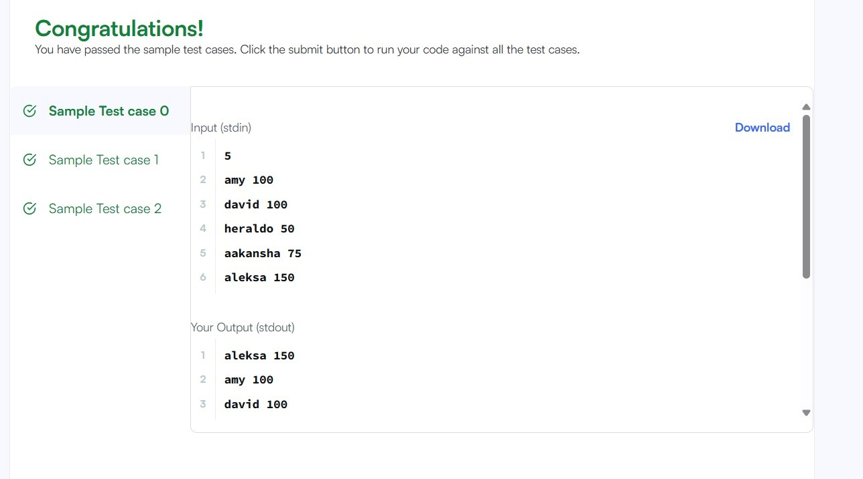
OUTPUT:

- Java Comparator – https://www.hackerrank.com/challenges/java-comparator/problem

PROBLEM STATEMENT:
Comparators are used to compare two objects. In this challenge, you'll create a comparator and use it to sort an array.
The Player class is provided for you in your editor. It has 2 fields: a name String and a score integer.
Given an array of n Player objects, write a comparator that sorts them in order of decreasing score; if 2 or more players have the same score, sort those players alphabetically by name. To do this, you must create a Checker class that implements the Comparator interface, then write an int compare(Player a, Player b) method implementing the Comparator.compare(T o1, T
o2) method. Input Format
Input from stdin is handled by the locked stub code in the Solution class. The first line contains an integer, , denoting the number of players.
Each of the subsequent lines contains a player's and , respectively. Constraints
- 0<=score<=100
- players can have the same name.
- Player names consist of lowercase English letters.

Output Format
You are not responsible for printing any output to stdout. The locked stub code in Solution will create a Checker object, use it to sort the Player array, and print each sorted element.
Sample Input 5
amy 100
david 100
heraldo 50
aakansha 75
aleksa 150 Sample Output aleksa 150
amy 100
david 100
aakansha 75
heraldo 50

PROGRAM:
class Checker implements Comparator<Player> { @Override
public int compare(Player a, Player b) { if (a.score != b.score) {
return b.score - a.score;
}
return a.name.compareTo(b.name);
}
}
class Player{ String name; int score;
Player(String name, int score){ this.name = name; this.score = score;
}
}
class Solution {
public static void main(String[] args) { Scanner scan = new Scanner(System.in); int n = scan.nextInt();
Player[] player = new Player[n]; Checker checker = new Checker(); for(int i = 0; i < n; i++){

player[i] = new Player(scan.next(), scan.nextInt());
}
scan.close(); Arrays.sort(player, checker);
for(int i = 0; i < player.length; i++){
System.out.printf("%s %s\n", player[i].name, player[i].score);
}
}
}

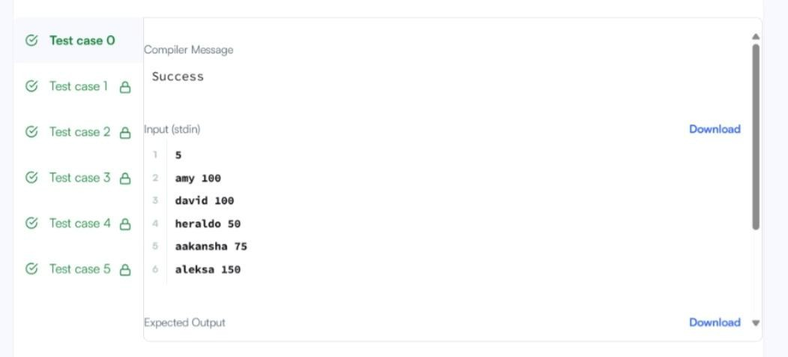
Output:

SESSION-4: Higher-Order Functions
2.Richest Customer Wealth – https://leetcode.com/problems/richest-customer-wealth/

PROBLEM STATEMENT:
You are given an m x n integer grid accounts where accounts[i][j] is the amount of money the i^{th} customer has in the j^{th} bank. Return the wealth that the richest customer has.
A customer's wealth is the amount of money they have in all their bank accounts. The richest customer is the customer that has the maximum wealth.

Example 1:
Input: accounts = [[1,2,3],[3,2,1]]

Output: 6
Explanation:
1st customer has wealth = 1 + 2 + 3 = 6
2nd customer has wealth = 3 + 2 + 1 = 6

Both customers are considered the richest with a wealth of 6 each, so return 6.

Example 2:
Input: accounts = [[1,5],[7,3],[3,5]]

Output: 10
Explanation:
1st customer has wealth = 6 2nd customer has wealth = 10 3rd customer has wealth = 8
The 2nd customer is the richest with a wealth of 10.

Example 3:
Input: accounts = [[2,8,7],[7,1,3],[1,9,5]]

Output: 17
Constraints:
- m == accounts.length
- n == accounts[i].length
- 1 <= m, n <= 50
- 1 <= accounts[i][j] <= 100

PROGRAM:
class Solution {
public int maximumWealth(int[][] accounts) { int max=0;
for(int person=0;person<accounts.length;person++){ int sum=0;
for(int account=0;account<accounts[person].length;account++){ sum+=accounts[person][account];
}
if(sum>max){ max=sum;
}
}
return max;
}
}

OUTPUT:
